**GOOGLE C LOUD TERRAFORM CODE**

Google provider

-------------------------------

provider "google" {

credentials = file("google key.json") **NOTE:=======need to keep google key under project folder**

project = "tf-dev-project"

region = "south-asisa1"

zone = "south-asisa1"

}

Note: google key. JSON on file store under project

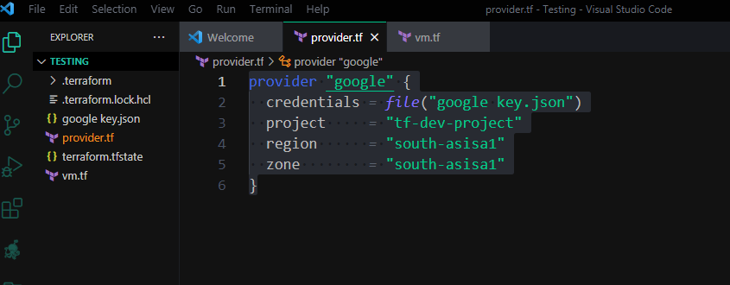

provider "google" {

  credentials *=* *file*("google key.json")

  project     *=* "tf-dev-project"

  region      *=* "south-asisa1"

  zone        *=* "south-asisa1"

}

VM CREATION DETAILS

resource "google_compute_instance" "VM1" {

    name    *=*"VM1dev -Dev"

    machine_type *=* "f1-micro"

    zone *=* "asia-south1-c"

    boot_disk {

      initialize_params{

          image *=* "debian-cloud/debian-9"

      }

    }

  network_interface {

    network *=* "defalut"

    access_config {

    }

  }

}

**Required service account permission on iam & admin**

|  |  |  |  |
| --- | --- | --- | --- |
| terrafrom-service@unified-runner-321113.iam.gserviceaccount.com | Terrafrom-service | Compute Admin  Compute Network Admin  Kubernetes Engine Admin  Service Account Admin  Security Center Admin |  |